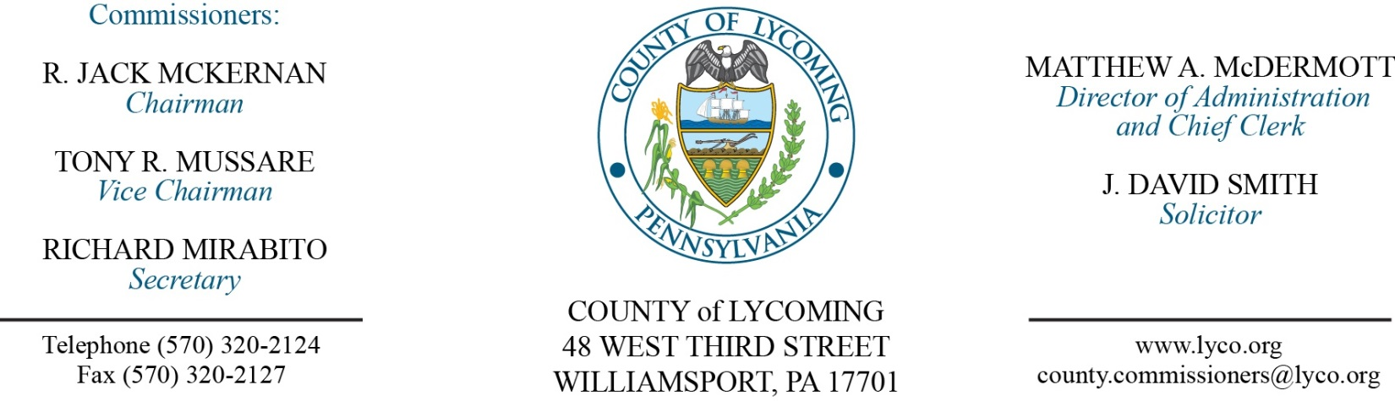
Commissioners’ Meeting Agenda
September 8, 2016

Opening Prayer

Pledge to the Flag

1.0 OPERATIONS

1.1 Convene Commissioners’ meeting.

1.2 Approve the minutes of the previous meetings.

1.3 Receive public comments (agenda items only).

2.0 ACTION ITEMS

2.1 Approve CJAB Technical Assistance and Training Grant Application in the amount of $1,440.00. (Mya Toon)

2.2 Adopt resolution 2016-19 accepting donation from the First Community Foundation Partnership of Pennsylvania made possible by the Muncy Bank & Trust Company Fund in the amount of $12,500 to be used for the Muncy Resiliency Program. (Fran McJunkin)

2.3 Approve the following personnel actions: (Roxanne Grieco)
DPS – communications – Samantha L. Garlick as full time replacement Telecommunictor I – WOE – pay grade 6 - $16.42/hour effective 9/12/16.
PCD – Austin J. Daily as full time replacement Temporary Zoning/Subdivision Officer – Pay grade 6 - $32,001.58/annually effective 9/12/16.
Public Defender – John Rickert as full time replacement Paralegal – Pay grade 6 - $16.42/hour effective 9/12/16.
RMS – Business Office – reclassification of Jessica R. DiBartolomeo as full time replacement Clerk III/AP Weighmaster – Pay grade 4 - $14.74/hour effective 9/11/16.
RMS – promotion of Heather M. Snyder as full time replacement Clerk III/Weighmaster – Pay grade 4 - $13.81/hour effective 9/25/16.

2.4 Approve termination agreement with Sungard Public Sector Inc. (Krista Rogers)

Recess Commissioners’ Meeting

4.0 BOARD of ASSESSMENT REVISION

4.1 Convene Board of Revision.

4.2 Approve the following refunds:
Chad Gray & Jennifer McCarty - $438.22, Veteran’s Exemption.
CFC Muncy Properties - $3891.85, Court Order from Appeal.

4.3 Approve the following exonerations:
28-203-113 Dan Baylor Truman Run Rd
27-001-518-003 Mary Lewis 3605 Lyc Ck Rd Lt 3
27-001-518-003 Mary Lewis 3605 Lyc Ck Rd Lt 3
41-352-118.12 CFC Muncy Properties LLC 76 O'Dell Rd.

4.4 Adjourn Board of Assessment Revision.

Reconvene Commissioners’ Meeting

5.0 REPORTS/INFORMATION ITEMS

5.1 STEP Americorps information. (Emily Gail and Daryl Kern)

6.0 PUBLIC COMMENT:

7.0 NEXT REGULARLY SCHEDULED MEETING: Planning Session on Tuesday, September 13, 2016.

8.0 ADJOURN COMMISSIONERS’ MEETING.

